JENKINS INSTALLATION

JENKINS: Tool that is used for automation, and it is an open-source server that allows all the developers to build, test and deploy software. It works or runs on java as it is written in java. By using Jenkins, we can make a continuous integration of projects(jobs) or end-to-endpoint automation.

1.Sign-In to AWS Console: Launch a Instance.

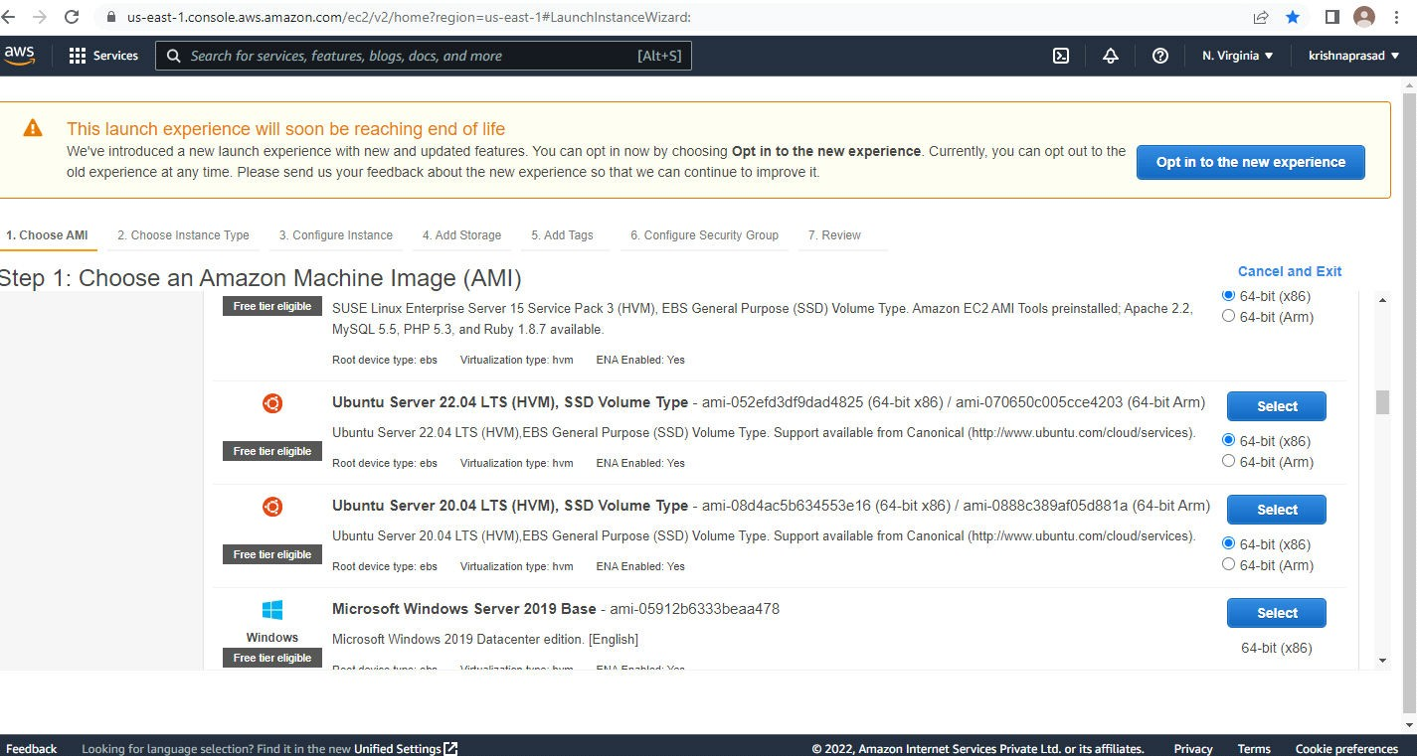

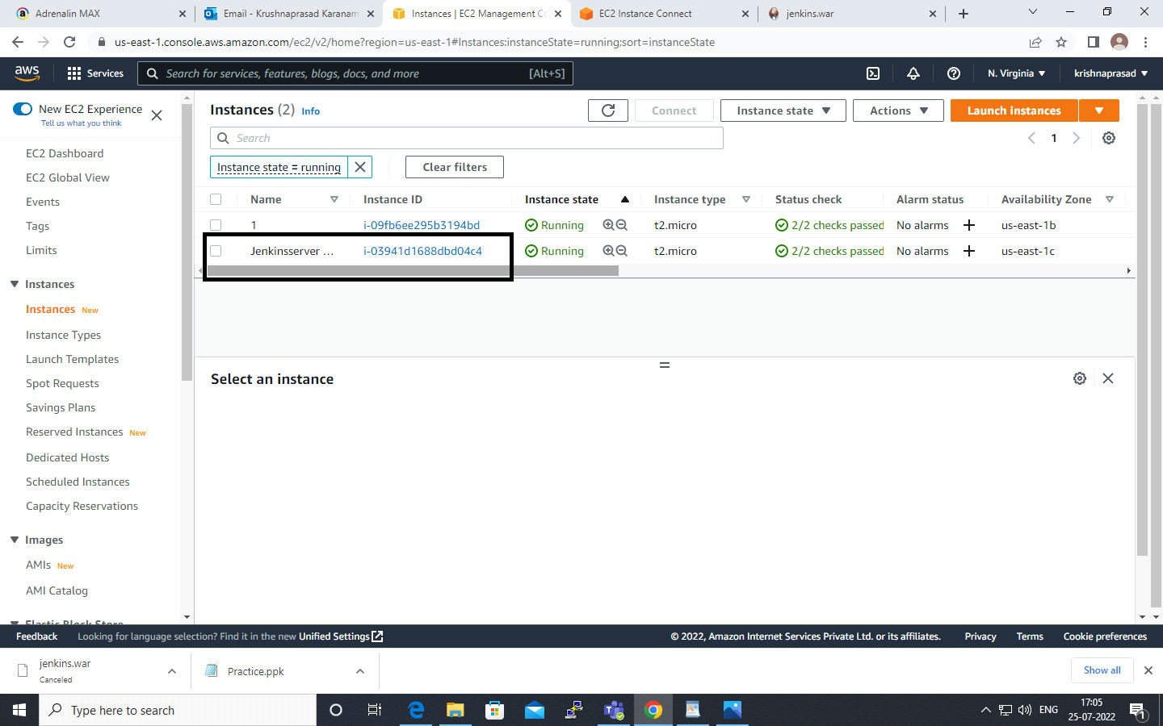

Step 2: After 2/2 checks pass connect the instance from the browser. Use “ sudo su -” for switch the root user for super user do permission access.

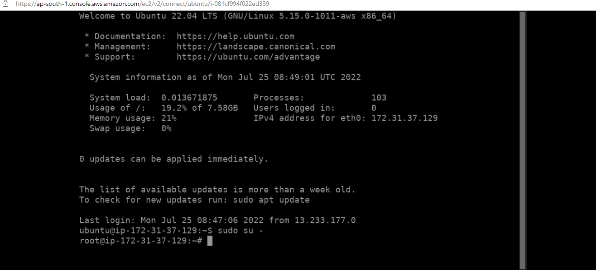

Step 3: use “sudo apt-get install -y openjdk-11-jdk" command installation of JAVA.

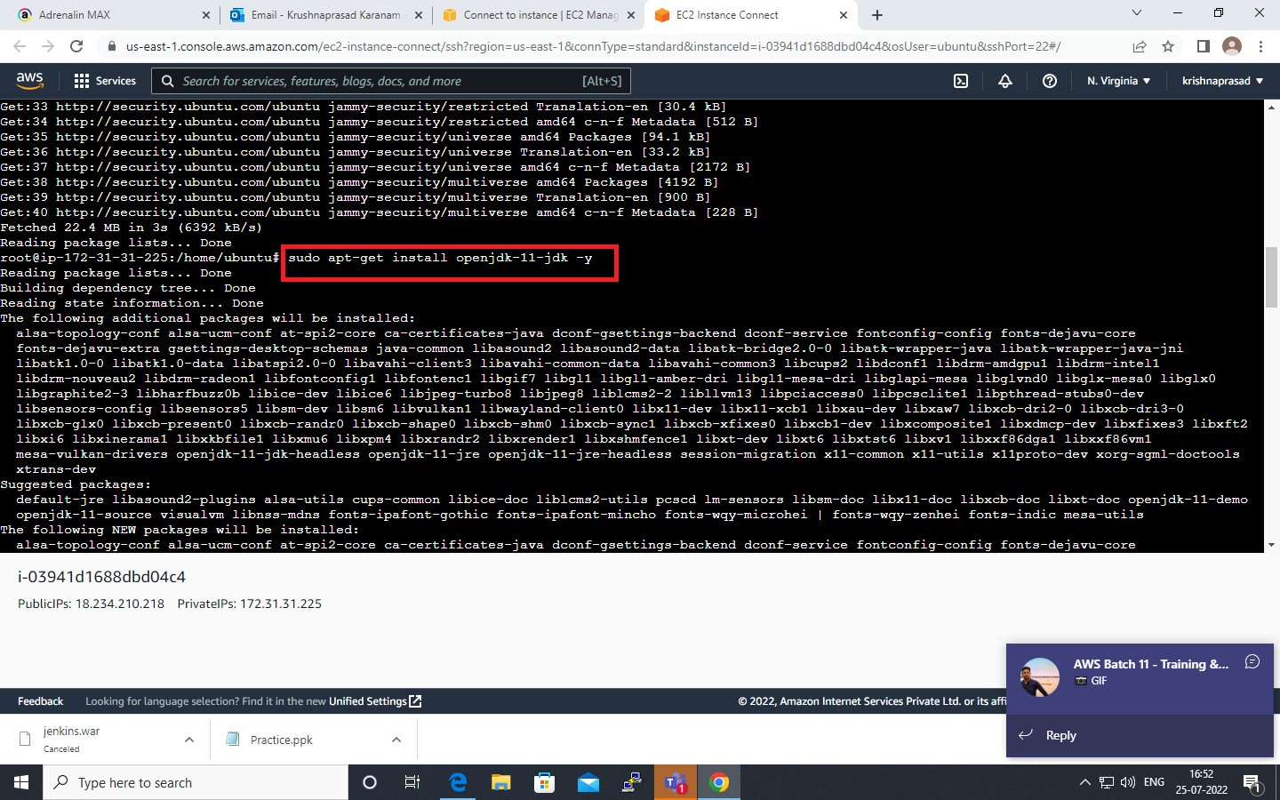

Step 4: “sudo apt-get update –y" command used to updates the package index files to get the latest list of available packages in the repositories.

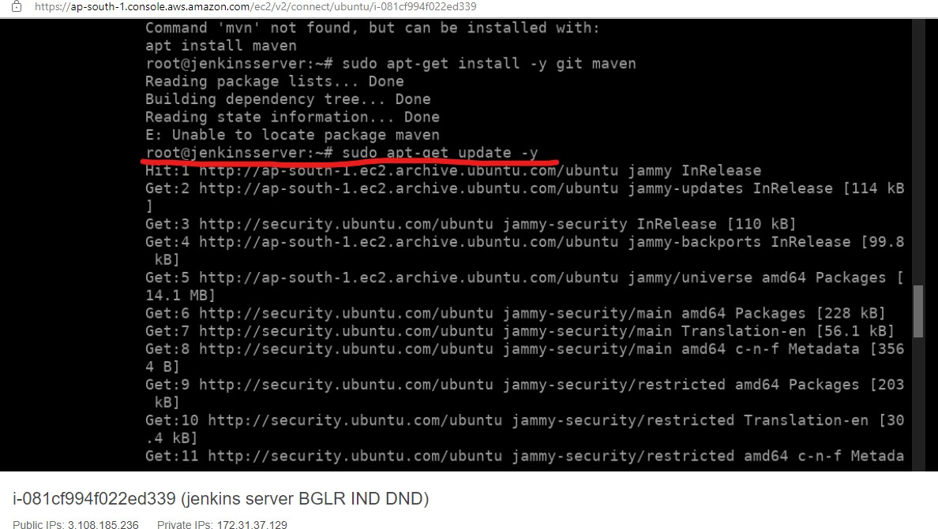

Step 5: commands “java --version” and “git --version” are used for check the version of application which are installed.

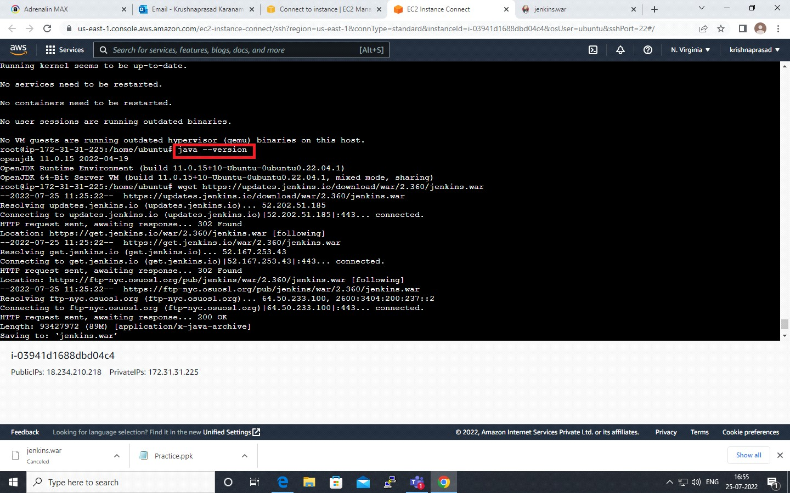

Step 6: command “ wget <https://get.jenkins.io/war-stable/2.263.4/jenkins.war>“ for download the war file by the url.

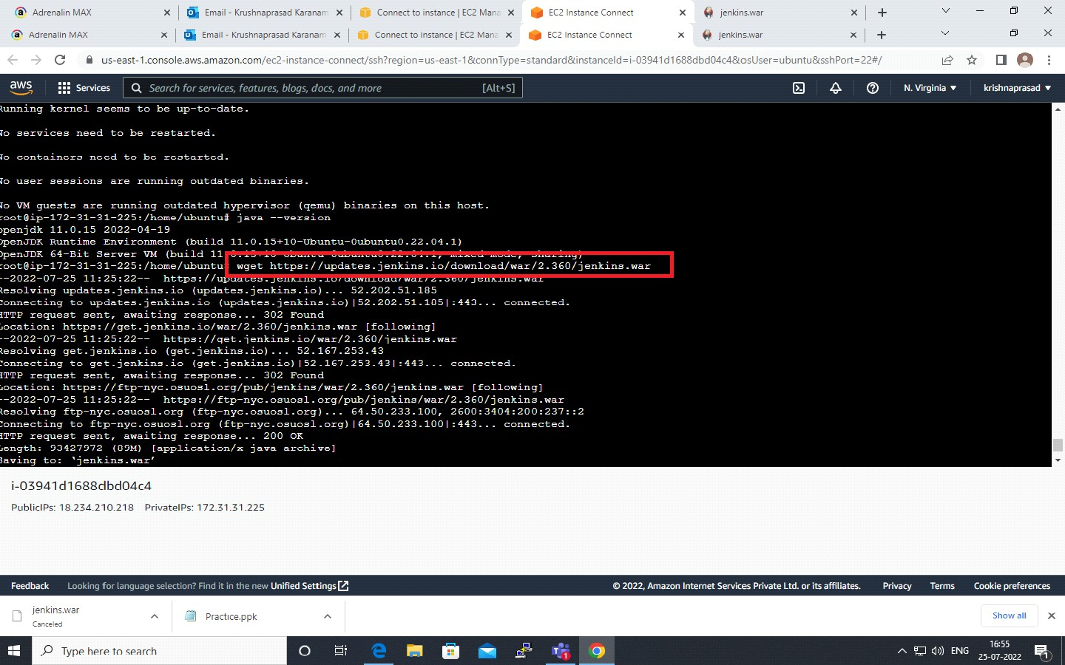

Step 7: “ java -jar jenkins.war” for run the junkins. And copy the password which generated end of the script.

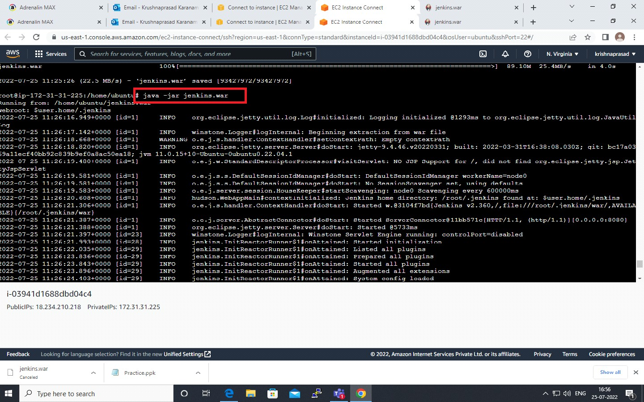

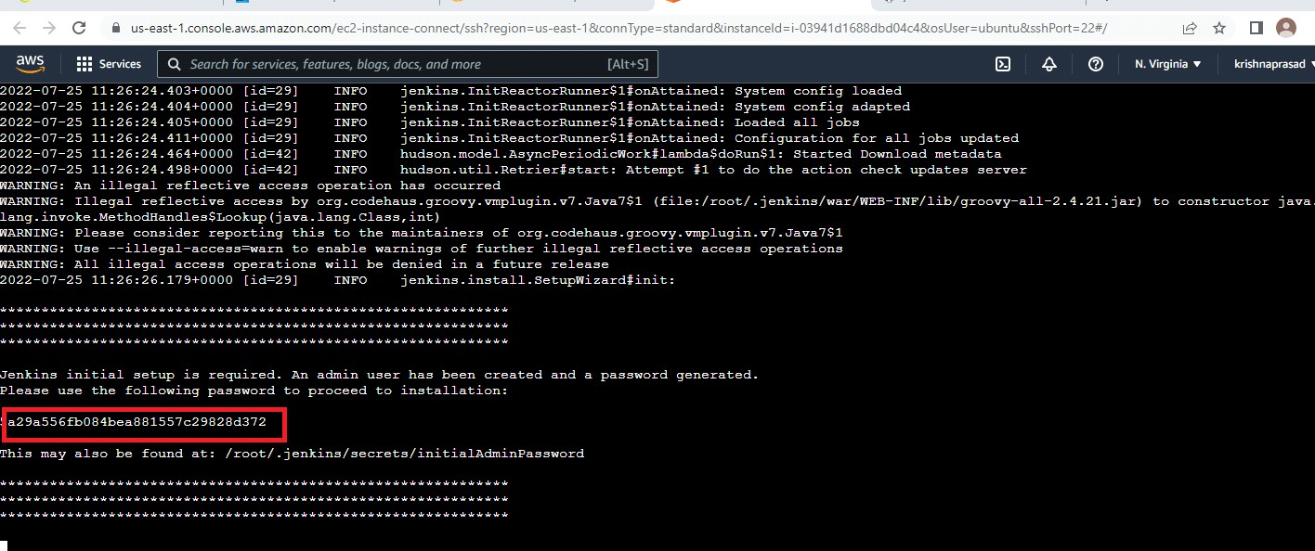

Step 8: After jenkinsup >> open the local browser enter the Public ip:8080 (172.31.31.225:8080) ,Paste the administrator password which are copied in previous.

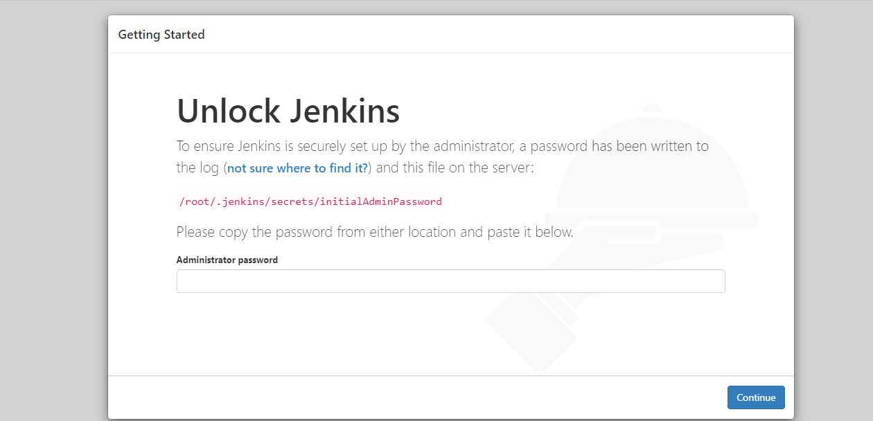

Step 9: Next customize jenkins >> choose the install suggested plugins for best practice.

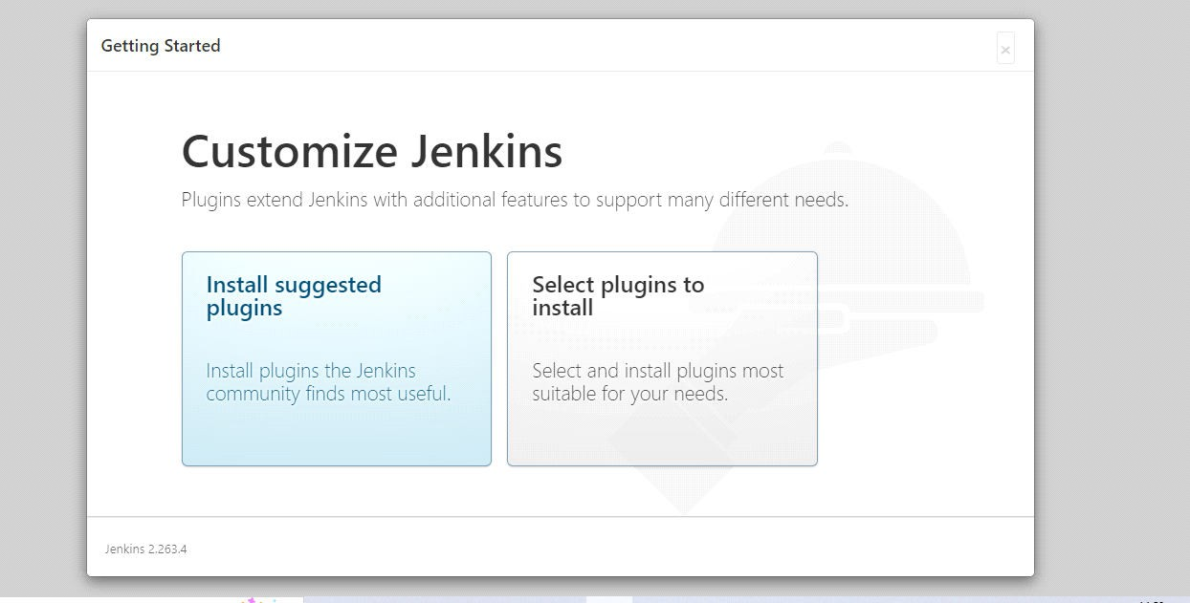

Step 10: create the user profile, for access the jenkins.

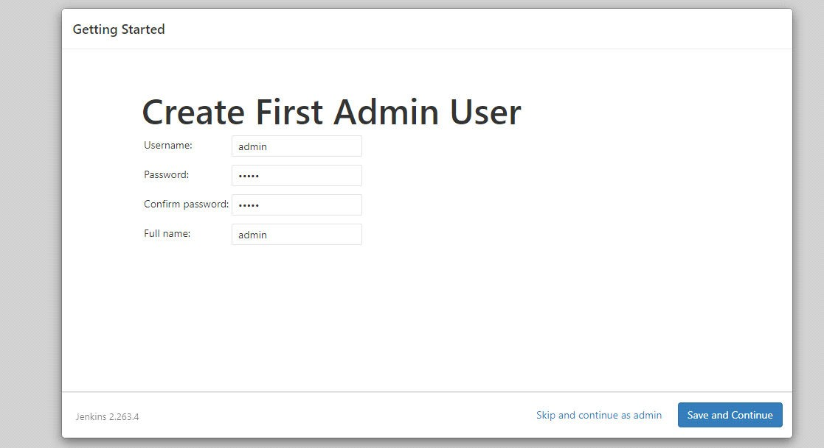

Step 11 : Completed the Installation, The jenkins dashboard will appear as shown in the below picture.

